**Exercise 1**  
**1.1** x receives the properties from the object ‘product’  
  
**1.2**

const product = {

    name: 'Xiaomi rice cooker',

    price: 1700,

    brand: 'Xiaomi',

    color: 'White'

    };

    for (let x in product) {

    console.log(`${x}: ${product[x]}`);

    }

2.

const task = {

    subject: 'Implement login feature',

    createdBy: 'Hoang Ngoc Duc',

    assignTo: 'Nguyen Phuong Nam',

    dueDate: '2019-10-08T18:00:24+0000',

    expectedHours: 0.5,

    };

//line needed

({subject, dueDate, assignTo} = task);

//test

console.log(subject);

console.log(dueDate);

console.log(assignTo);

Results:

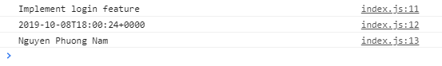  
  
**3.1** The outermost layer’s data type is object (assuming jobSearch counts as a layer).  
  
**3.2** Hits is an array  
  
**3.3** The job details are found in the drop down menu in hits’ items after jobSearch has been logged out.